**Exp No:** 8 **Date:** 19/10/2020

**Name:** Swetha Saseendran

**Reg No:** 185001183

CASE CONVERSION

## Aim:

To program and execute case conversions using 8086 microprocessor using DOSBOX.

## Algorithm:

* Count carries the value od number of characters.
* In a loop input characters. Compare input value with 60h.
* If AL>60h, move to upper.
* Else add 20h.then move to skip.
* In Upper subtract 20h from AL.
* In skip output character using mov functions.
* End the program.

|  |  |
| --- | --- |
| PROGRAM | COMMENT |
| ; Program to convert case  **ASSUME** CS: CODE, DS: data  **data SEGMENT**  COUNT equ 10h  **data ends**  **CODE SEGMENT**  **START:** MOV AX, data  MOV DS, AX  MOV CX, COUNT  L1:MOV AH,1,  INT 21H  CMP AL,60H  JNC UPPER  ADD AL,20H  JMP SKIP  **UPPER:** SUB AL,20H  **SKIP:** MOV AH,2  MOV DL, AL  INT 21H  LOOP L1  MOV AH,4CH  INT 21H  **CODE ENDS**  **end start** | DEFINE DATA SEGMENT  LOOP COUNTER  INPUT CHARACTER    IF AL IS greater THAN 60  CONVERT TO UPPER CASE  CHARACTER OUTPUT FUNCTION  CHARACTER MUST BE IN DL  DISPLAY THE CHARACTER  REPEAT LOOP  TERMINATE THE PROGRAM |

## Unassembled Code:

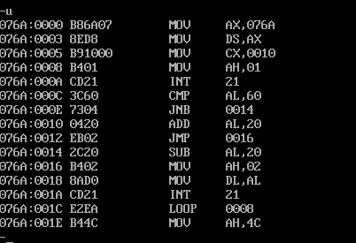

## Snapshot of sample input and output:

**INPUT:**

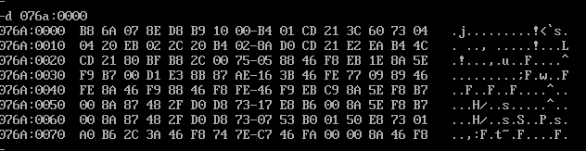

**OUTPUT:**

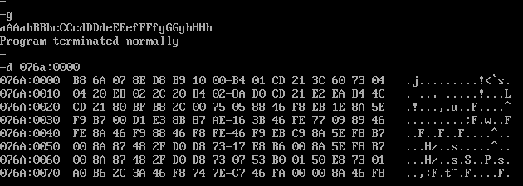

# Result:

The assembly level programs were written to perform the above specified system operations and the output was verified.